

Appointment Management System

User Manual

Prepared By:

Sven Frei (2022828866)

Muhammad Harith Azmi (2022920135)

Intan Syafiqahanum Binti Burhanudin (2022981555)

Na'bil bin Saperi (2022971889)

Table of Contents

**Home Page** 3

**Login Page** 4

**User’s Home Page** 6

1. Homepage 6

2. Set Appointment Page 7

3. Patient’s Appointment List Page 8

4. User’s Edit Account Page 9

**Doctor’s Homepage** 10

1. Homepage 10

2. Doctor’s Appointment List Page 11

3. Doctor’s Edit Patient’s Appointment Page 12

4. Doctor’s Edit Account and Manage Absence Page 13

# **Home Page**

This is the homepage for our website, where the user has not logged in or register to the website. From here, they can click the login button to start.

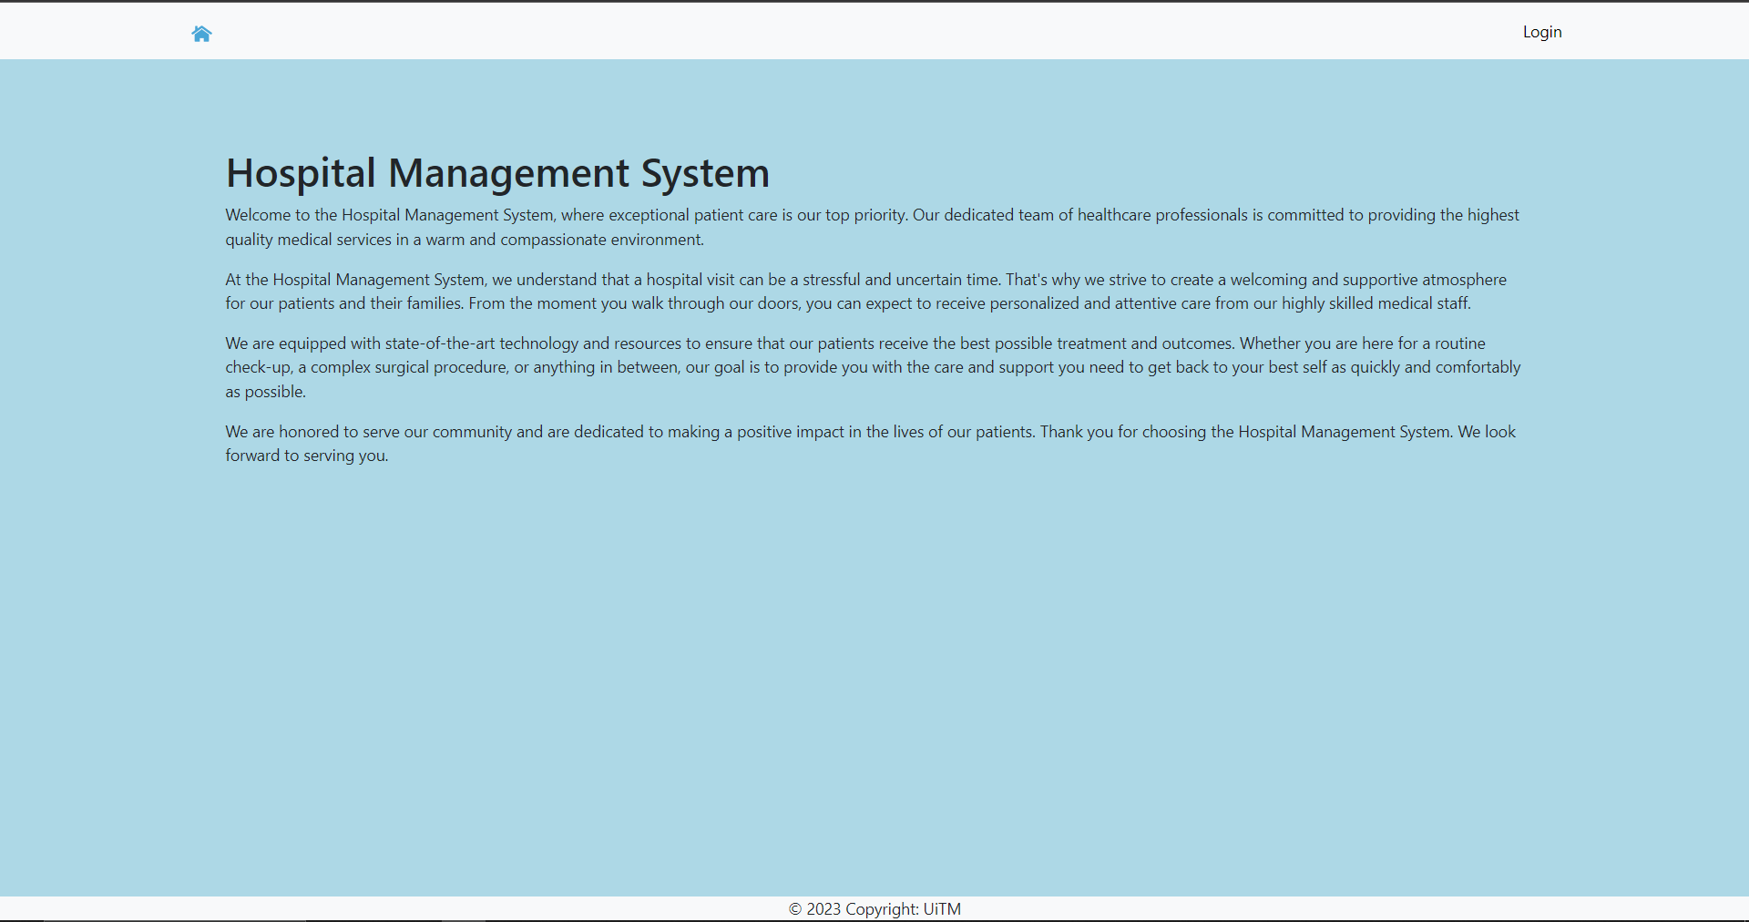

# **Login Page**

Users who have registered to the system can login by entering the correct email and password. The users who have not registered can click the ‘Register Now’ button to create a new account

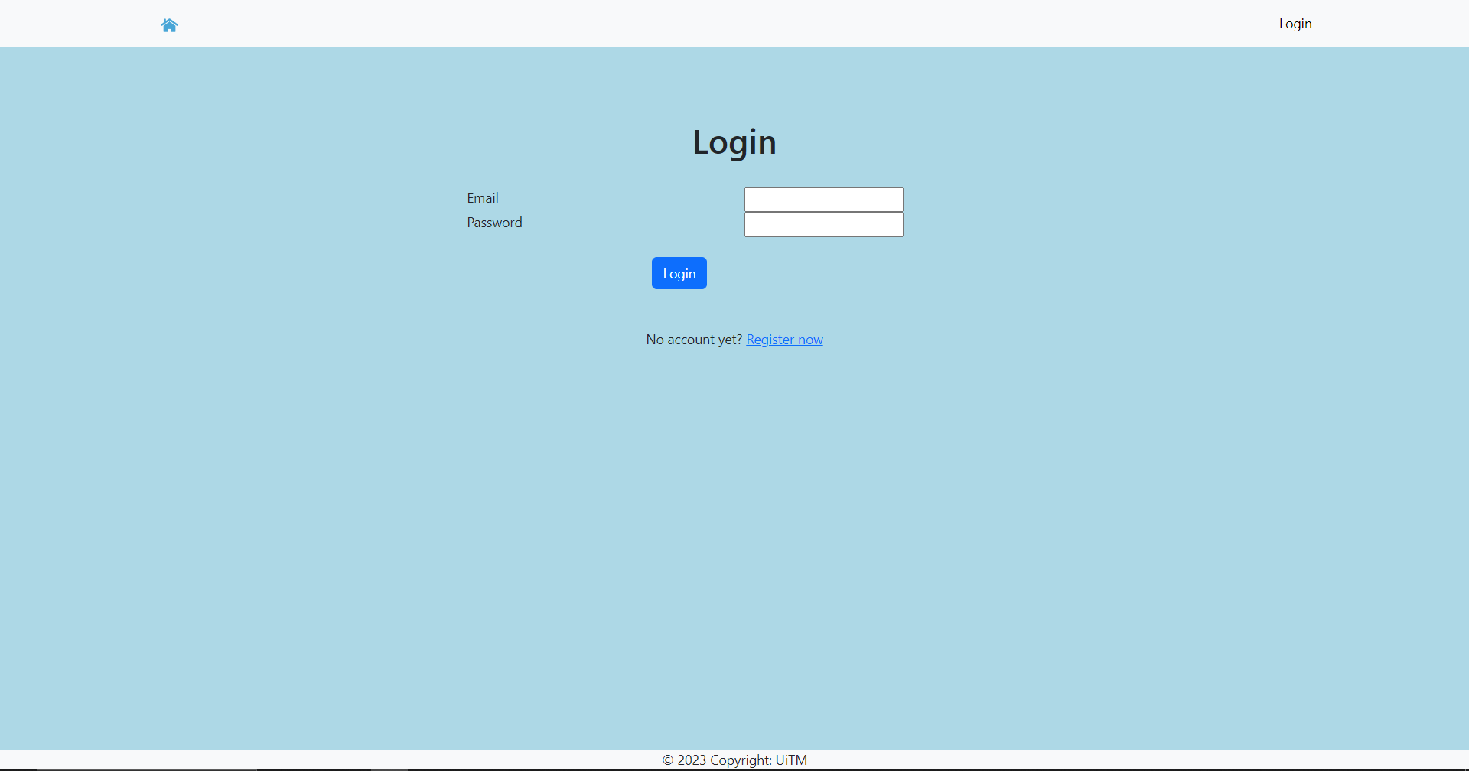

Input correct email and password to login

Click to login

Navigate to registration page

**Registration Page**

Users who have not registered can enter their information into the registration form. After making sure the information is correct, they can proceed to click the register button. After that, they can log in to the website.

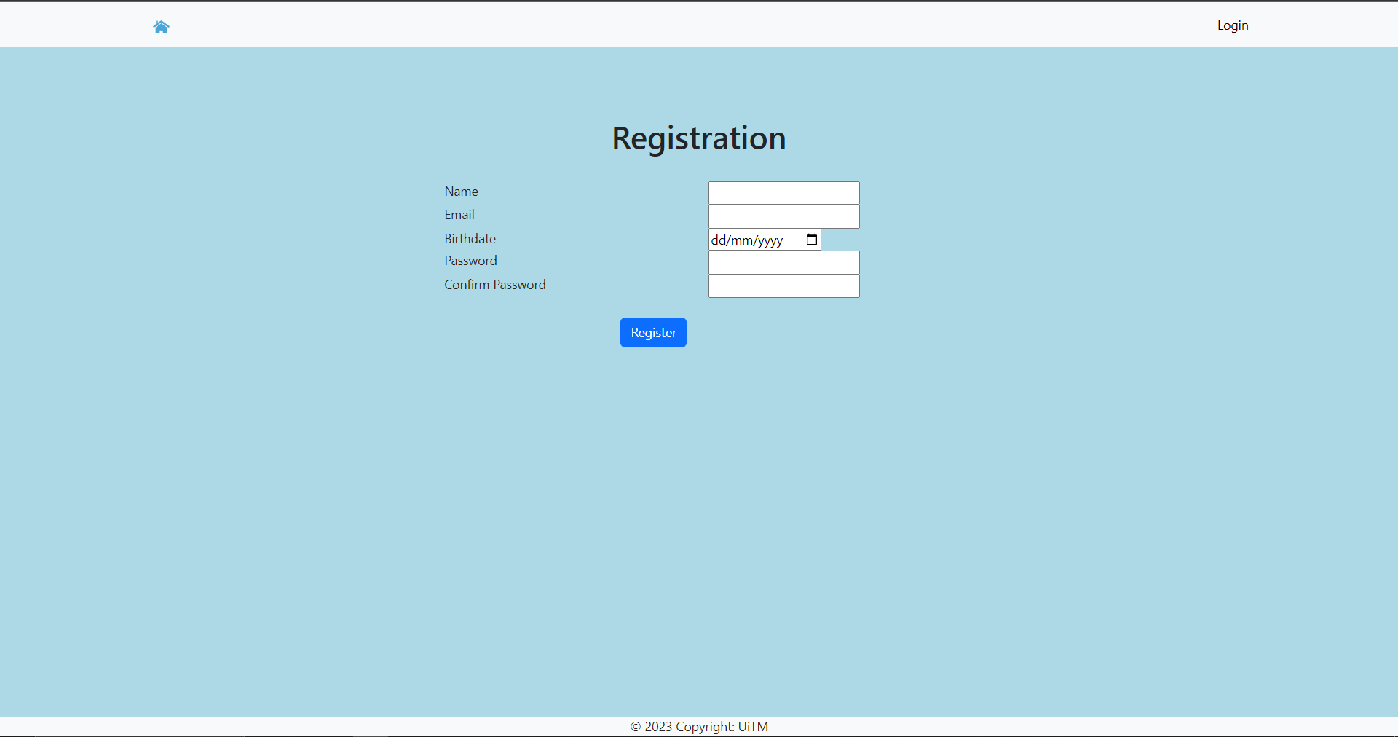

Click the button to register

Input all information required

# **User’s Home Page**

## Homepage

Navigation Bar:

Home – Navigate to Homepage

Set Appointment – Navigate to create appointment page

List My Appointment – Display the list of appointment created

Edit Account – Change user’s information and details.

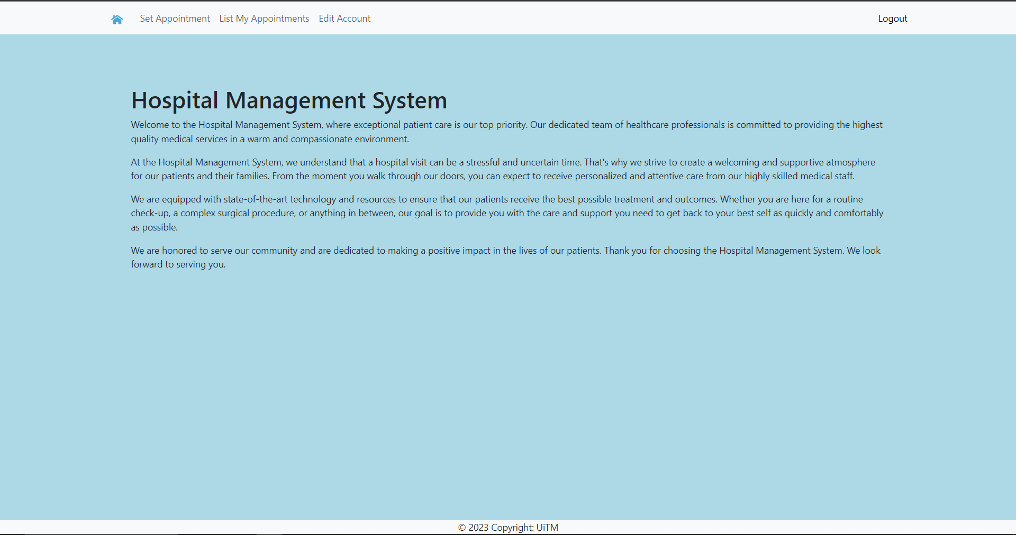

Click to logout

Navigate to edit patient’s account

Navigate to patient’s appointment list

Navigate to set appointment page

## 2. Set Appointment Page

This page allows patient to create an appointment by choosing a doctor and setting the date and time for the appointment.

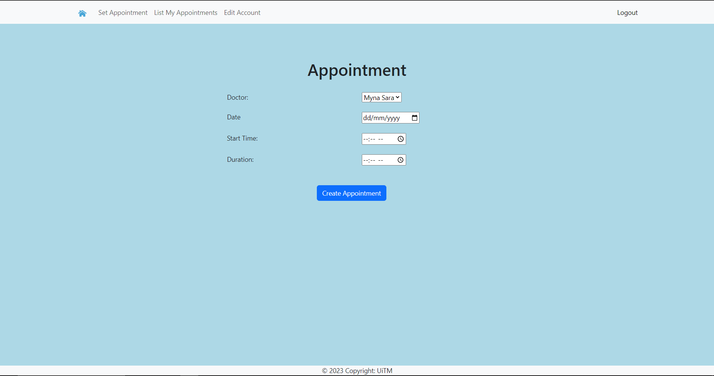

Set time for appointment

Choose doctor and date for appointment

Click to create appointment

## 3. Patient’s Appointment List Page

From here, the patient can check the information about their appointment and they can also edit their appointment or delete it if they want to cancel the appointment that have been set.

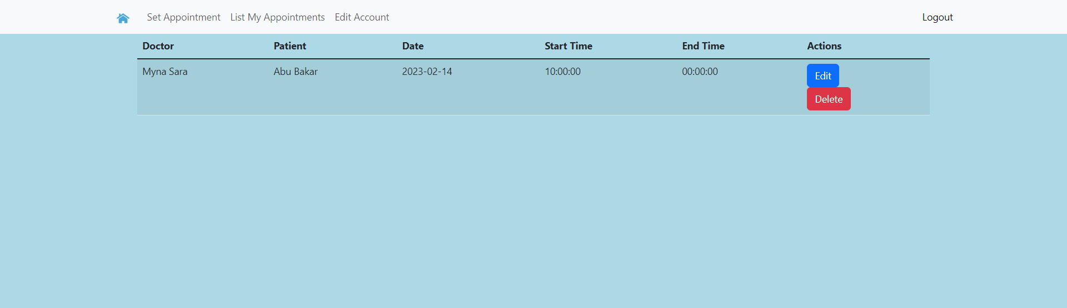

Click to delete the appointment

Click to edit the appointment date

Display the information of patient’s appointment

## 4. User’s Edit Account Page

The patient can edit their information here, either fixing an error in their information or adding missing information.

After doing such changes, they can proceed to update the account by clicking the button below.

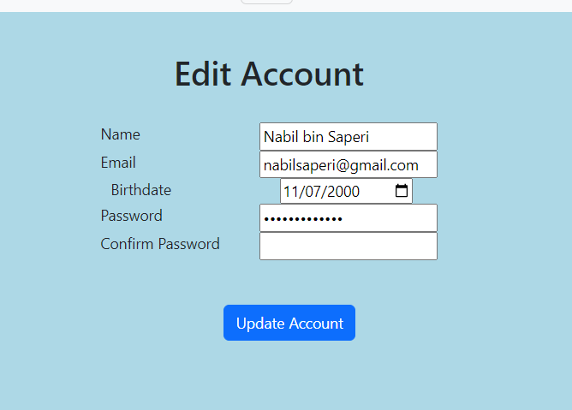

Change the user’s information if needed update

Click to update the user’s account

# **Doctor’s Homepage**

## Homepage

Navigation Bar:

Home – Navigate to Homepage

Set Appointment – Navigate to create appointment page

List My Appointment – Display the list of appointment created

Edit Account – Change user’s information and details.



Navigate to set appointment page

Navigate to doctor’s appointment list

Click to logout

Navigate to edit doctor’s account

## Doctor’s Appointment List Page

From here, the doctor can check the appointments that they have and they can also update the appointment if they want to change the date or delete the appointment if it is cancelled or the doctor is unavailable for that day.

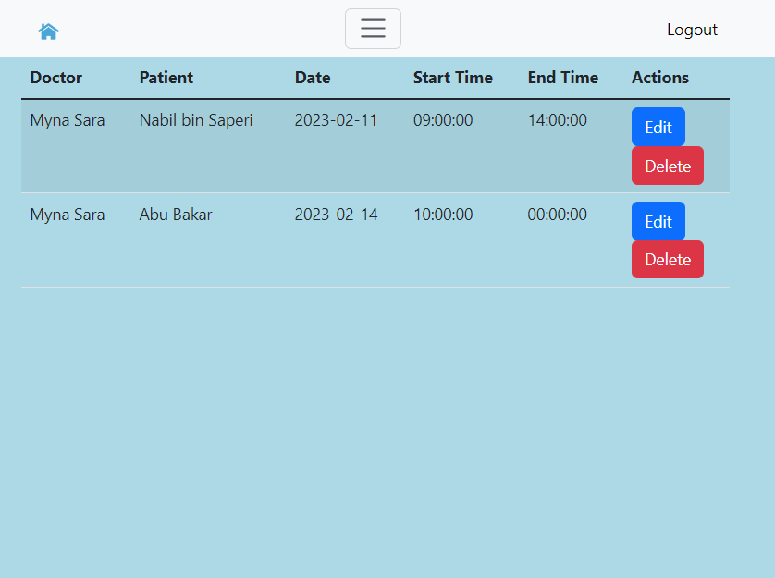

Click to edit the patient’s appointment info

Click to delete the patient’s appointment

## Doctor’s Edit Patient’s Appointment Page

From here, the doctor can update the appointment information such as the date and the time. After making the changes, they can proceed to click the ‘Update Appointment’ button.

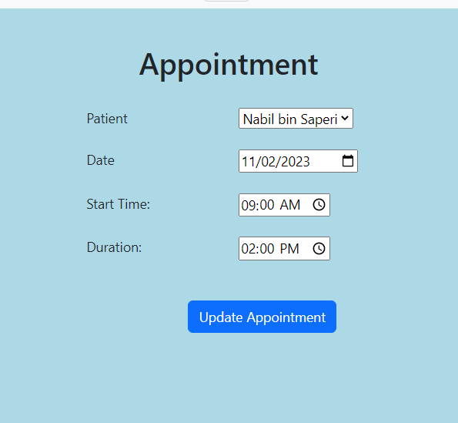

Change the patient’s date and time of appointment

Click to update the patient’s appointment

## Doctor’s Edit Account and Manage Absence Page

From here, the doctor can update their own information here if some need to be changed. After that, they can proceed to click the button to update the information, after entering the correct password.

At the ‘Manage Absences’ the doctor can set the date when they are not available for the appointments. They can proceed to click the ‘Add Absence’ after entering the date, and they also can update the date of their absence and delete it.

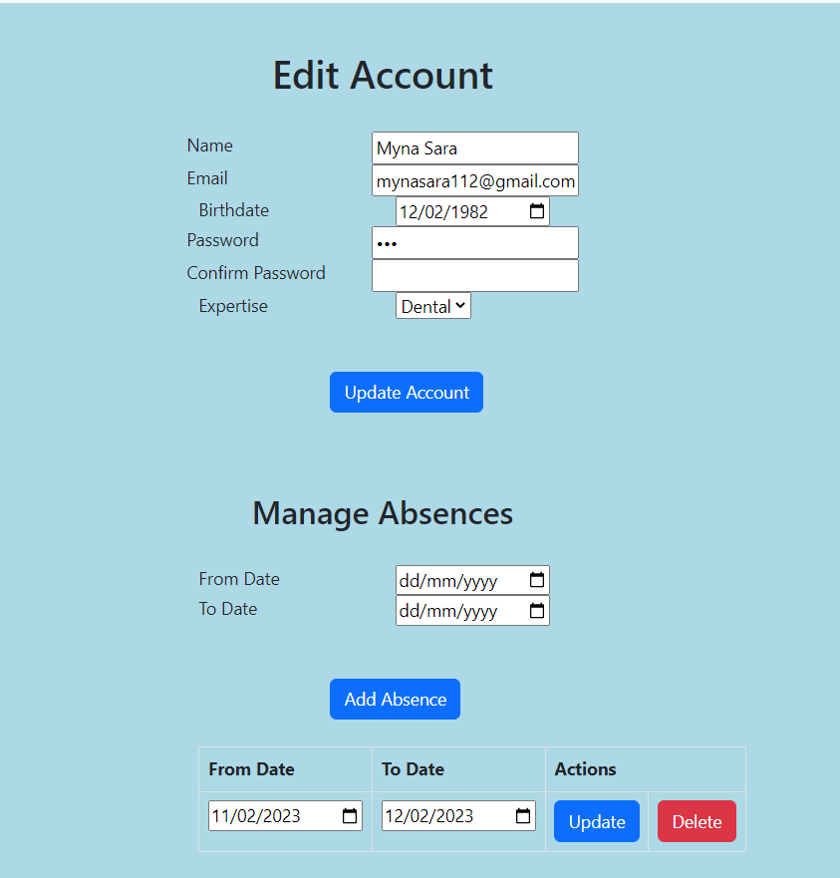

Set the date for the doctor’s absence

Display the date of absence

Update the date of absence by clicking this

Delete the absence date

Click to update the doctor’s account

Update the information of the doctor and their expertise if needs correction